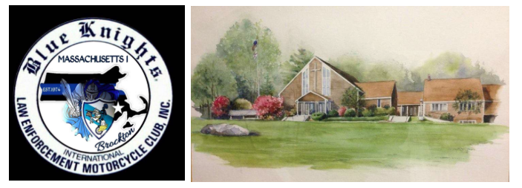
Blessing of the Bikes
Sunday, May 20th 2018
Gathering: 11:45
Trinity Episcopal Church
414 Sumner Street, Stoughton, MA
Blue Knights MA I Chaplin, Father Philip Jacobs and Father Harry Walton will bless the bikes at 12:00.
Food and Beverage available after the blessing, come and see the motorcycles and talk with the riders!
There is no charge for this event, donations are welcome at the conclusion of the ceremony.
Anyone interested in attending worship services prior to the blessing are welcome to do so. Services start at 09:00.

